COMP 4175 Software engineering

Homework: System Modeling

Points Possible: 100
Submission via Cougar view
This is an individual assignment.
Learning Objectives:
- To understand system modeling
- To apply system modeling skills to help us design
- To understand different modeling types

Questions:
1. [10 points] Explain what system modeling can do for us.
System modeling is used to better understand the functionality of the system. It allows us to communicate with clients and users. System modeling is great to document the system for implementation. Modeling helps to design projects into static and dynamic views. Also, model types can show different perspectives.

2. [30 points] Develop a sequence diagram our group project - A Smart Class Planning Tool, showing the interactions involved.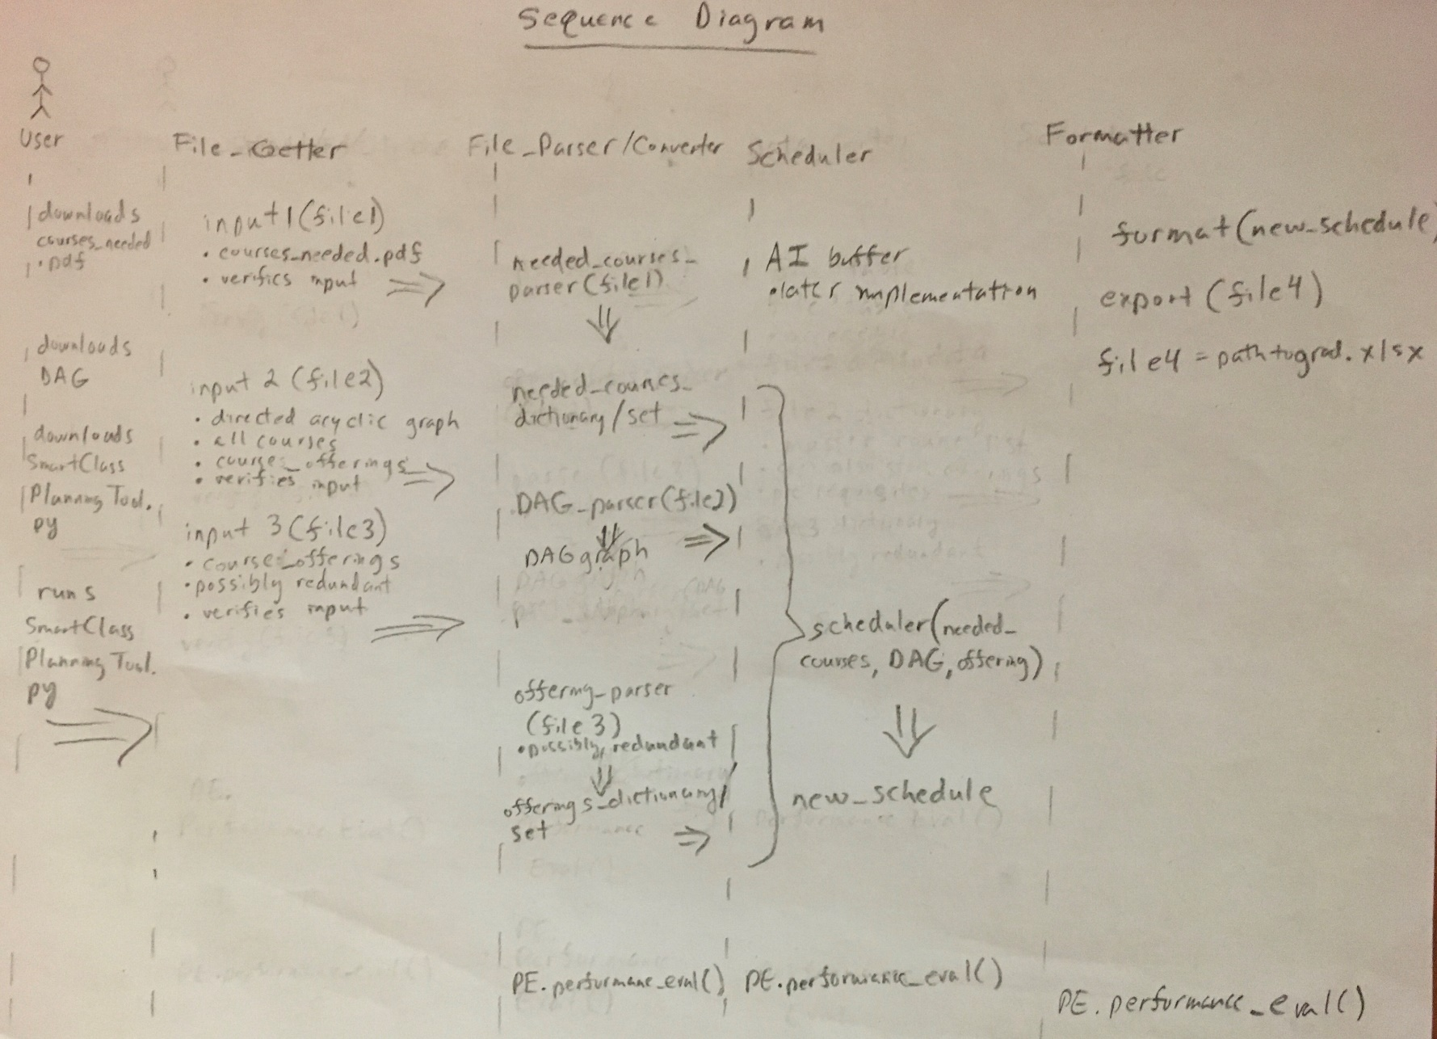

3. [30 points] Develop a data flow diagram for our group project - A Smart Class Planning Tool.
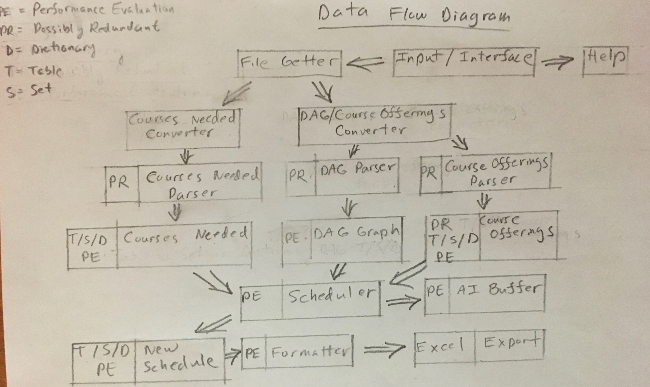

4. [30 points] Develop a program structure diagram based on your data flow diagram.
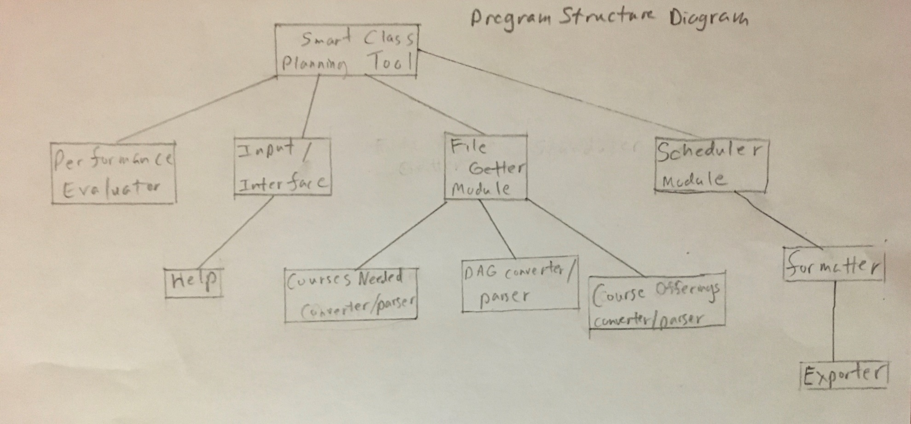

Submission:
- Submit your solution as a PDF file named as ““hw_modeling.pdf” through Cougar view

